Name: Sandesh Varma                                                                      Date: 08/09/2025

Roll No: CH.EN.U4CSE22078

Experiment No: 5

___________________________________________________________________

Aim: To implement Symbol Table.

**Algorithm:**

1. Start the Program.
2. Get the input from the user with the terminating symbol ‘$’.
3. Allocate memory for the variable by dynamic memory allocation function.
4. If the next character of the symbol is an operator then only the memory is allocated.
5. While reading, the input symbol is inserted into symbol table along with its memory address.
6. The steps are repeated till “$” is reached.
7. To reach a variable, enter the variable to the searched and symbol table has been
8. Checked for corresponding variable, the variable along its address is displayed as result.
9. Stop the program

Code:

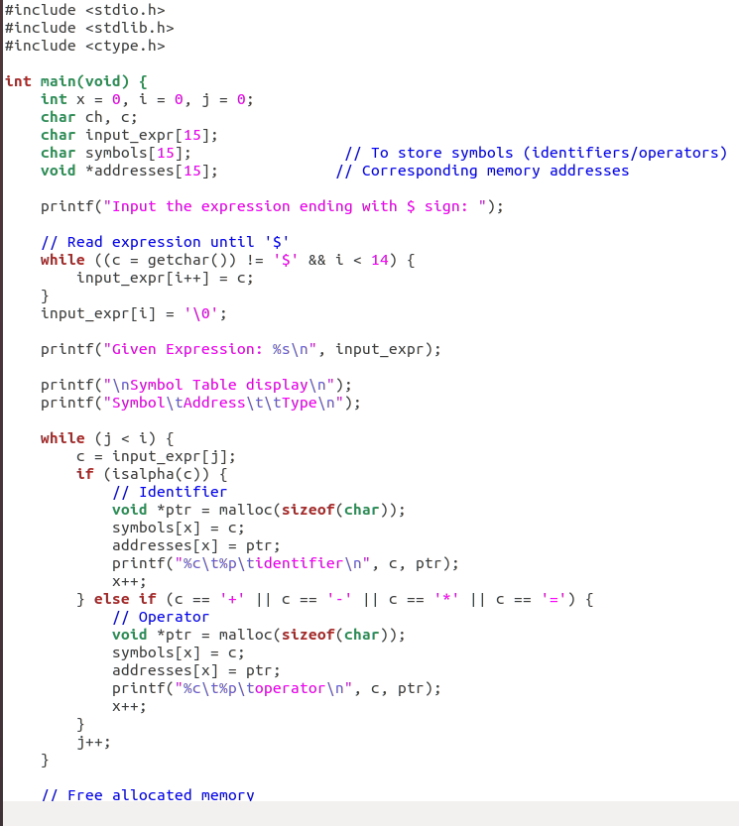

Sandesh Varma

CH.EN.U4CSE22078

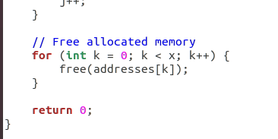

Output:

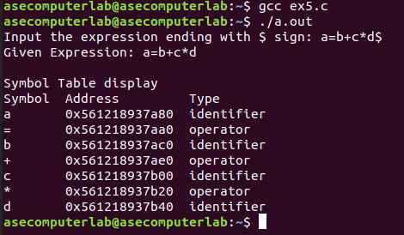

Results: The program for symbol table implementation has been executed successfully.